**Brooklyn torah gazette**

**For parshas matos-masei 5783**

Volume 7, Issue 43 (Whole Number 350) 26 Tammuz 5783/ July 15, 2023

**Printed L’illuy nishmas Nechama bas R’ Noach, a”h**

For a free subscription, please forward your request to [***keren18@juno.com***](mailto:keren18@juno.com)

**Focusing on Our Jewish**

**Mesorah When Dealing**

**With Life’s Challenges**

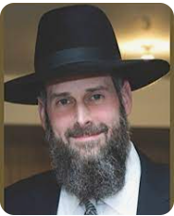

**Rabbi Yosef Viener**

Rabbi Yosef Viener, Rav of K’hal Sha’a Hashomayim in Monsey was a featured speaker at the recent Flatbush Memorial Day Hakhel Yarchei Kallah Event.

The topic of his lecture was “Managing Expectations, Dealing with Disappointment and Utilizing the Anchor of Our Mesora.” He began by declaring that our mesora (traditions) is the key to understanding our bitachon (trust in Hashem).

He noted that we find in the Gemara Tractate Shabbos 88a the story of the Sadducee who challenged the famous amora Rava:

There was a Saduccee who saw Rava studying a Talmudic matter. Rava had put the fingers of his hands under his legs and he was crushing them [as he intensely studied the Torah subject at hand] and his fingers were flowing with blood.

The Sadducee said to Rava, “Oh impulsive one, who put their mouth before their ears. You still persevere in your impulsiveness. First you should have heard the commandments so you would know whether you are able to accept them. And if you did not hear them first, you should never have accepted them!”

**The Punishment for Those**

**Lack Faith in Hashem**

How does Rava respond? Quoting from Mishle (Proverbs 11:3) he tells the Sadducee:

“For those of us who go in the ways of complete faith, it is written about us “The perfect faith of the upright shall lead them.” For those people who go in the way of perverseness, it is written about them, “and the perverseness of the faithless shall destroy them.”

Rava’s response, according to Rabbi Viener is that Hashem has a great love for us (the Jewish people) and anything that He commands us to do are things that we are indeed capable of doing and furthermore it is for our own good. A nisayon (a seeming challenge from Hashem) is only something that we can handle.

In the zechus of avoseinu (the merits of our forefathers) at Har Sinai where our forefathers accepted [for all future generations] the Torah nasa v’nishma (before we even knew what was expected of us,) Hashem rewarded us with rachamim (abounding mercies). This, Rabbi Viener said teaches us for the need to especially develop strong bitachon (trust in Hashem.)

**A Young Man’s Reaction to a**

**Possible Shidduch Disappointment**

A young man recently told Rabbi Viener that he was involved with a shidduch (a matrimonial match) and that if the woman nixed it, he would feel very depressed. The truth is that if the shidduch works out successfully it is really only from Hashem and we are only blessed with siyate di’shamaya (heavenly assistance) after we go through our motions of hishtadlus (seemingly logical efforts). And even if the shidduch does fail, that too is from Hashem.

People who today are increasingly concerned about the environment and fear that the world is coming to an end are guilty of falling into a dangerous belief of kefira (heresy) that is basically a denial of the truth that it is Hashem who is running the world.

The challenge is do we want to live a life of bitachon, trust in Hakodesh Baruch Hu or do we want to take Him completely out of the equation and try to save the planet on our own.

One of the great fears of many who don’t want to live their lives on the basis of Hashem’s commandments, such as perevu (populating the world with children,) is the argument that we have to limit the number of children in our families. They base this on a concern or fear that we won’t have enough food for a growing or exploding population.

**Major Companies Have Solved**

**The Threat of Mass Starvation**

This however, Rabbi Viener says doesn’t take into account that major companies like Monsanto have for many decades been regularly creating and designing seeds that have produced much larger harvests that have as a result eliminated any serious threat of mass starvation for a rapidly increasing world.

Indeed, so many countries in the industrialized world as well as many developing nations such as China and India have promoted efforts to lower the birth rates that most countries in Europe, North America and Japan have a new challenge ahead and that is the danger of serious population declines.

**Major Negative Impacts of a Declining Population**

Some of the possible negative impacts of a declining population are a rise in the dependency ratio which would increase the economic pressure on the workforce to support many more retired individuals who have stopped working as well as a crisis in end-of-life care for the elderly because there are insufficient caregivers for them.

Rabbi Viener with frustration has pointed out that all too many scientists look into the Torah and take the opposite opinion as in the case the commandment to multiply and have children. Without Hakodesh Baruch Hu, our lifestyle would be pretty tenuous

In conclusion Rabbi Viener urged the Hakhel audience to understand that our answer to the doomsday nay-sayers is not to have less children and at the same time not to lose our bitachon, trust in Hakodesh Baruch Hu’s ability to fulfill His promises to us if we as Jews act as His holy light to the rest of the world.

*Reprinted from this week’s edition of The Jewish Connection.*

**The “Real” Reason for the Request of the Tribes of Reuven and Gad to Moshe**

**From the Teachings of the Lubavitcher Rebbe**

**Rabbi Menachem Mendel Schneerson, Zt”l**

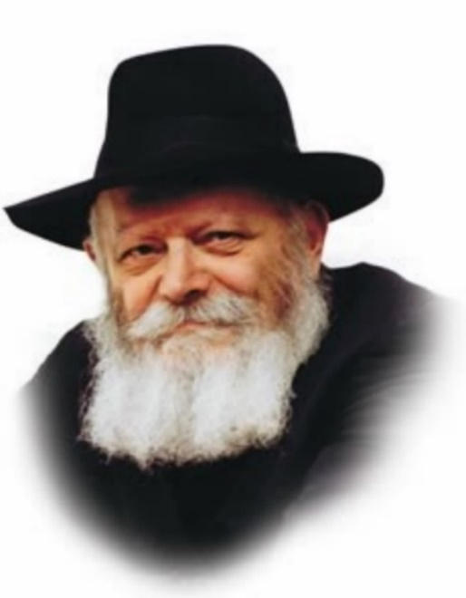

The first of this week's two Torah portions, Matot, contains a seemingly unusual request by the tribes of Reuben and Gad. Citing their "great multitude of cattle," the sons of Reuben and Gad asked Moses to grant their portion of the land of Israel on the other side of the Jordan.

"The country...is a land for cattle; and your servants have cattle," they said. "If we have found grace in your eyes, let this land be given to your servants as a possession; do not compel us to go over the Jordan."

Even more surprising is the fact that Moses acceded to their request. How many verses in the Torah speak of G-d's promise to Moses to bring the Children of Israel into the promised land? Yet these verses mention only "the land of Canaan," an area west of the Jordan river.

If so, why would the tribes of Reuben and Gad have even considered settling in the cities of "Atarot, Divon, Ya'zer and Nimrah" on the eastern shore of the Jordan, part of the land of Sichon and Og? Did these tribes intentionally seek to distance themselves from their brethren?

Furthermore, how valid was their claim that the territory east of the Jordan would provide superior grazing land for their cattle? Why would the tribes of Reuben and Gad have willingly forgone entering the promised land with their wives and children just to benefit their livestock?

In order to understand what really occurred we need to refer back to G-d's very first promise to Abraham concerning the land of Israel. At that time, G-d said to Abraham, "To your seed will I give this land...the [land of] the Keni, the Kenizi and the Kadmoni..."

In all, G-d enumerated ten nations that the Jewish people would one day inhabit. Seven of these nations were defeated by the Children of Israel soon after they left Egypt; the other three will only be conquered by the Jewish people in the Messianic Era.

**A Preparation for the Ultimate Messianic Era**

The true intent behind the request of Reuben and Gad to dwell east of the Jordan was in order to hasten this process. The portion of land they settled, formerly belonging to the kings Sichon and Og, was part of the territory of the three nations that still remained to be conquered. This is the reason Moses agreed to their request and granted them their inheritance east of the Jordan, for he saw their settlement of that territory as a "preparation" for the full and complete settlement of the land of Israel that would occur in the Messianic Era.

In truth, the actions of the tribes of Reuben and Gad lent an added dimension to the Jews' first conquest of the land, one that brought our ultimate conquest of the entire land of Israel in the Era of the Redemption much closer.

*Reprinted from the Parshat Matos-Masei 5760/2000 edition of L’Chaim. (Adapted from a talk of the Lubavitcher Rebbe.)*

***If a man makes a vow to the L-rd* (Num. 30:3)**

The Torah teaches that vows are praiseworthy, terming them "a fence around abstinence," yet at the same time states that "the [existing] prohibitions of the Torah are sufficient." How do we reconcile these two statements? A person who conducts himself properly is not encouraged to abstain from worldly matters. On the contrary, he is obligated to work "within" the world, in order to elevate and sanctify the physical plane of existence. A person whose conduct is deficient, however, can sometimes prevent further deterioration by means of vows. (Likutei Sichot)

*Reprinted from the Parshat Matos-Masei 5760/2000 edition of L’Chaim.*

**Rav Avigdor Miller on How Can We Say “Baruch Atah” to Hashem?**

**Isn’t That a Lack of Respect?**

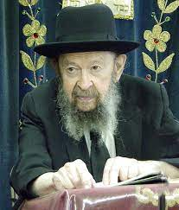

***ANSWER:*** *You have to realize that Hakadosh Baruch Hu is looking down from the skies – right now He’s looking down – to see if anybody is thinking about Him. And when you say “You” to Hashem, then immediately He is interested in you. When you say “You” and you’re thinking about what you’re saying, then you are making Hashem real and tangible in your mind. And that’s what Hashem wants from you.*

*You say Atah – “You”! You’re speaking with Hashem and He’s listening to you. Absolutely He’s listening! ‘Atah shomeia’ – You are Listening. Get that into your bones, into your blood.*

*You have all this foolishness from the outside world trying to make Hakadosh Baruch Hu disappear from the world. And you’re fighting against that foolishness by saying Atah– “You.”*

*We’re the Jewish people, and we’re bringing Hashem into the world. The more you say Hashem’s name, the more you daven, the more you talk about Him, the more you’re bringing Him into this world.*

*It’s a world of wickedness, of foolishness, today – more than ever before. And we need the Presence of Hashem in this world as much as possible.*

*“You Hashem will not hold back Your mercy from me.” It doesn’t say “Hashem.” It says “You, Hashem.” That’s what Hashem wants. He wants you to feel Him in a tangible way. He wants you to say “You.” If you say “You” to Hashem, Hashem will say “you” to you.*

*Reprinted from the Parshas Korach 5783 email of Toras Avigdor based on Rabbi Miller’s Tape classic Thursday night lectures.*

**Thoughts that Count**

*He shall not break his word; he shall do according to all that proceeds out of his mouth* (Num. 30:3)

The commandment to carry out one's verbal declarations was given primarily to the "heads of the tribes" - to the leaders of the Jewish people. As authority figures, they are responsible for setting the highest standards for the rest of the community. That is why the Talmud states in Berachot: "Concerning one who recites the Shema but [his words] do not reach his own ears, Rabbi Yosai opines that he has not fulfilled his obligation." A person must never chastise or reproach another unless he has first applied the same criticism to himself. (Mei'otzareinu HaYashan)

*These are the journeys of the people of Israel* (Num. 33:1)

There is nothing in macrocosm that does not also exist in microcosm. On the spiritual level, the 42 journeys of the Jewish people are reenacted in the life of every Jew, from the moment he is born till his last day on earth. (The Baal Shem Tov)

In the entire narrative of the Jewish people's journeys through the desert, the Hebrew letter "zayin" does not appear even once. This alludes to the fact that they did not journey on Shabbat ("zayin," with a numerical equivalent of seven, alludes to the seventh day), and that they did not need to resort to weapons ("zayin" also means weaponry or arms). (Ahavat HaTorah)

*Reprinted from the Parshat Matos-Masei 5783 email of L’Chaim, a publication of the Lubavitch Youth Organization in Brooklyn, NY.*

**Rabbi Berel Wein on**

**Parshat Matot-Maasei 5783**

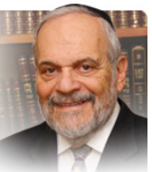

The narrative of the experiences of the people of Israel in the desert of Sinai concludes with the parshiyot of this week. All of the occurrences, successes and failures that marked this forty-year trek in a wasteland wilderness are alluded to in the count of Israel in last week’s parsha - and in the listing of all of the way stations of that excursion.

The Torah seems to be determined to remind all later generations of Jews of the experiences in the desert. Moshe, in his final oration in the book of Dvarim, will once again review the events of the desert for a new generation of Jews distanced in time and circumstance from Egyptian bondage. The Torah is aware of human forgetfulness.

It will take only one generation to forget Egypt and even Mount Sinai. History is boring and quite irrelevant to new generations. Yet forgetting the Jewish past is the ultimate betrayal of Judaism and Jewish hopes. All of us, as we become older, begin to feel a psychological and spiritual need growing within us to be remembered.

The Baal Shem Tov is reputed to have said: “Forgetting is the true exile.” Of course, it is obvious that ignorance is the true partner of forgetfulness. In fact, if one never knew anything then one cannot be accused of having forgotten it. The Torah emphasizes the repetition of all the facts and experiences of Jewish life in the desert of Sinai so that this knowledge will enable and strengthen the powers of national remembrance.

Much of the Jewish world today suffers from a severe case of, hopefully temporary but nevertheless intense, amnesia. In spite of all of the efforts of the survivors, the museums, the academic courses and books relating to the Holocaust, this event is rapidly disappearing from world and even Jewish memory.

Religious Jewry has found no way, as of yet, to ritually remember the Holocaust. Without ritual and holiness, it tragically will continue to fade from the memory of the coming generation. In distributing films and audio lectures about the Holocaust and the founding of the State of Israel to Jewish schools worldwide I am already encountering apathy if not sometimes even outright opposition to the insertion of the subject into the curriculum of schools.

One principal asked me: “Will it help my students to be admitted to Harvard or Yale?” And on the other end of the spectrum of Jewish education another principal told me: “Will it increase their ability to study Talmud properly?” I responded that the Torah listed all of the desert way stations even though knowing them would also not guarantee Talmudic proficiency or admission to Harvard or Yale.

It is not only the amnesia regarding even our very recent past that afflicts us. It is our inability to grasp that the knowledge of this immediate past is vitally essential to our present and to our future. Without knowledge of the events of the past, dating back all of the way to the events of the desert of Sinai, we are creating for our descendants a new desert, a wasteland of ignorance, falsehoods and disillusion. It is not too late to correct this. If our schools won’t do so, let our homes and families attempt to do so.

Chazak, chazak, v’nitchazeik.

*Reprinted from the current website of rabbiwein.com*

**You Had Me at Shalom:**

**The Jewish Jerry Maguire**

**By**[**Rabbi Pinchas Landis**](https://aish.com/authors/575659791)

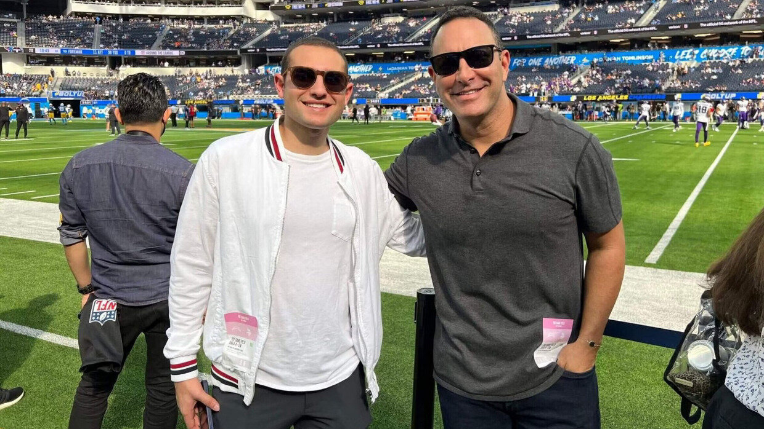

***The youngest agent in the NFL is also its only Orthodox Jew.***

With more than 800 certified agents in the National Football League (NFL), Ness Mugrabi has two things that make him unique. At 24, he is the youngest agent in the league and, to the best of his knowledge, the only one who is an Orthodox Jew.

How did an observant Syrian Jew from New York take the NFL by storm?

From a young age, Ness was a diehard Miami Dolphins fan even though he lived in New York. In 2011, the Dolphins got off to a rough start, losing the first six games of the season. With his ambition shining through, 12-year-old Ness called the Dolphins’ corporate office and asked to speak to coach Tony Sparano. The receptionist didn’t take the call too seriously, but Ness was persistent and kept calling.

Not knowing how to handle the pesky caller, the receptionist asked Reginald Sperling, the Dolphins’ guest services director, what to do. Sperling said to put his next call through to him. Sure enough, Ness called again. Sperling told Ness that the coach was in the middle of practice. The 12-year-old boy said that he just wanted to tell the coach to keep his head up and that he was supported by his fans.

Sperling was super impressed with Ness’s persistence just to show support and make another person feel better, and invited him and his family to an upcoming Dolphins-Giants game at MetLife Stadium in New Jersey. The Mugrabis were treated to field passes where they met the team and Coach Sparano, and got signed footballs. They enjoyed the game from the luxury of a suite, sitting together with Dolphin’s owner Steven Ross.

Later that season, the Mugrabis visited the Dolphin’s Stadium in Miami where they were treated to a five-star tour. Most importantly, Sperling ended up becoming a mentor to Ness.

**

***Ness, 12, with Tony Sparano***

Ness knew that his future was going to be in football. While studying at the Yeshiva of Flatbush, he spent every second he could learning about the sport. At the age of 16, he convinced his father to take him to the NFL Scouting Combine in Indianapolis. The Combine is a four-day, invitation-only event that allows scouts to evaluate that year’s top draft-eligible players. The teenager walked around introducing himself by saying, “I’m just trying to meet people and build a name for myself in the business.” And that he did.

One night at the Combine, Ness recognized an agent from Florida area named David Canter. He introduced himself and told him he was a big fan of his work. Taken aback, Canter thought this must be some kind of prank. Sports agents aren’t usually recognized in public, but that’s how deeply Ness had been studying the sport.

Ness asked if he could intern with the seasoned agent. Seeing the young man’s dedication to his goals, David agreed and set Ness up with a remote internship. The relationship grew stronger. Canter brought his up-and-coming talent into every part of the business before his twentieth birthday.



***Asante Samuel Jr., David Canter, Ness Mugrabi and Cody Barton.***

At the age of 22, Ness became the youngest agent in the NFL. Today, Canter refers to him as his “co-pilot.” Together, they have around 50 clients including Cameron Sutton, DeMarcus Walker, and Xavien Howard. They have one Jewish client, Michael Dunn, who plays for the Cleveland Browns.

**Commitment to His Faith**

For most, sports agency is a seven-days-per-week job, but Ness works tirelessly to get it done in six. No matter what is going on in the world of football, Fridays and Jewish holidays the phone gets turned off. Canter, who is also Jewish, marvels at Ness’s commitment to his faith. “He has had hundreds of excuses to not be a practicing Orthodox Jew, to use an excuse to say: ‘Just this one time, it’s just too important, I got to skip Shabbos.’ He never, ever, ever, ever, has taken the easy way out. He has never not kept kosher. He never has just crossed into the gray zone once. And that’s the greatest compliment of the man that Ness has become that I can give.”

There have been challenging moments. Two of the biggest deals that Ness has worked on (Demarcus Lawrence for $105 million and Xavier Howard for $95 million) were negotiated Friday afternoon right before Shabbat. “Thank God, we got it done in time. It seems like God makes it that nothing important happens in football on Shabbat.”

Ness doesn’t sleep much, regularly responding to emails and texts into the wee hours of the morning. But he always makes time for spiritual growth. “I’ve been reading Aish.com for years now, and I listen to TorahAnytime every day.”

Ness understands that the highest level of *tzedakah*, charity, is to help someone provide for themselves. For young talent coming from college to the NFL, things can be scary. “At the end of the day, it is a billion-dollar corporation, and they’ll do anything to save a few bucks on a player.” Ness teaches his clients the ropes and set them up for professional success and greatness.

Ness got married a few weeks ago to his wife, Lauren, and they live in the Syrian Jewish community of Brooklyn. Lauren wasn’t much of a sports fan before they met, but the young couple do whatever they can to build their marriage while building the business. Lauren joins Ness on business trips all the time and sits right beside him at training camps and games. “She’s my partner in this journey for greatness that we are on.”

**Representing the Jewish People**

With antisemitism on the rise, Ness sees that he can play a vital role in combatting it from the position he is in. Knowing that he represents the Jewish people to individuals that have not had a lot of interactions with Jews, he constantly strives to be an upstanding individual. The Talmud teaches ([Yoma 86a](https://www.sefaria.org/Yoma.86a?lang=he-en&utm_source=aish.com&utm_medium=sefaria_linker)) to “make the name of Heaven beloved through you.” This is what Ness strives to do every single day.

Ness recently reached out to Jewish Patriots owner Robert Kraft to see how he could get involved with his recently launched “Stand Up to Jewish Hate” initiative. “People just don’t understand Judaism. It’s my job, it's your job, it's every Jew’s job to combat antisemitism. The way we do it is to show that Judaism starts with being a good person. We do the commandments between man and man as much as we do the commandments between man and G-d.”

*Reprinted from the current website of aish.com Excerpts from this article were taken from*[*NFL’s youngest agent is ‘obsessed with greatness,’ but nothing overshadows his faith*](https://theathletic.com/4576150/2023/06/22/nfl-agent-ness-mugrabi-orthodox-jew/)*, an article published by The Athletic*

**Special Treatment for the Torah Scholars of Menashe**

The size of the territory on the east bank of the Yardein that Moshe Rabbeinu allocated to half of the shevet of Menashe, exceeds by far the areas that he parceled out to the shevatim of Gad and Reuven. In addition, only Gad and Reuven were given the land with the stipulation that they first help Bnei Yisroel conquer the land of Eretz Yisoel, whereas Menashe received the land unconditionally.

R' Naftoli Tzvi Yehuda Berlin, (HaNetziv) explains in Haamek Davar: Moshe foresaw that on the east side of the Yardein, regard for Torah would be at a low level. To infuse the light of Torah into this area, Moshe asked the great Torah sages of shevet Menashe, who were comprised of great talmidei chachomim, to settle on the east bank of the Yardein.

**One Should Seek a Torah Environment to Reside in**

To induce them to settle in this area, Moshe offered them vast territories. The land allotted to Menashe was actually inside Eretz Yisroel proper, but because of the potential influence their talmidei chachomim would exert on the shevatim on the east of the Yardein, Moshe asked half of shevet Menashe to settle on the east bank. HaNetziv teaches us from here that one should make an effort to seek out a Torah environment as one's place of residence. (Torah Treasures)

They traveled from the Wilderness of Sinai and encamped in Kivroth-hataavah (33:16). The literal translation of the name Kivroth Hataavah is the “grave of craving.”

The Chasam Sofer explains homiletically: The more one travels away from the Torah, the more vulnerable he becomes to the yetzer hara. One can become quickly trapped in the quicksand of passion.

**The Torah Helps One Overcome the Advance of Evil**

Our Sages teach that Torah is the only effective antidote to the yetzer hara (Kiddushin 30b). In a variation on this theme, R’ Nachum of Chernobyl and Tiferes Shlomo explain that Torah grants one the strength of character and the purity of soul to reject the advances of evil. When they traveled from Har Sinai armed with the Torah, they were able to bury their physical lusts and passions. (The Torah Treasury)

*Reprinted from the Parshas Mattos-Masei 5783 email of The Weekly Vort.*